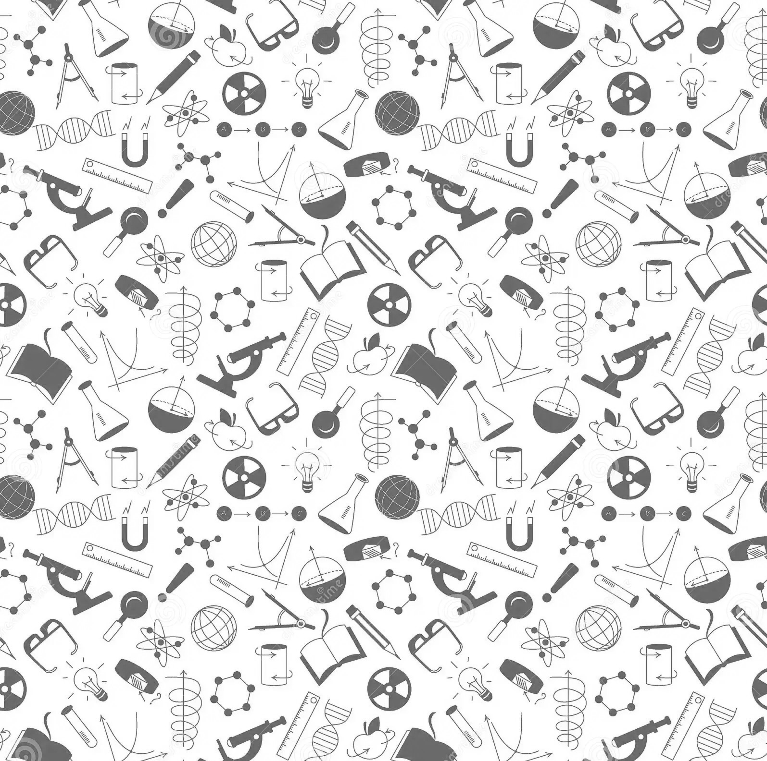

**Miss Starman: 8B Science**

**2023-2024**

**CONTACT INFORMATION:**

Miss Stacy Starman – Room 11

**Email:** [stacy.starman@pekin108.org](mailto:stacy.starman@pekin108.org)

**Website:** sstarman.weebly.com

**PLEASE NOTE:***Miss Starman will only reply to messages between the times of*

*7:30 a.m. and 3:30 p.m. on school days.*

**What do I need for class each day?**

* at least 2 pencils (plus extra lead if mechanical)
* colored pencils (at least 24 count)
* one 3-ring binder
* lined notebook paper
* 2 highlighters
* glue sticks (at least 5 or more)
* ruler
* scissors
* spiral notebook and matching folder (one subject or three subject, will stay in classroom)
* earbuds

**Science is all about effort! Put in the effort, ask for help, and don’t give up! You’ll be able to learn great things and, together, we can enjoy the school year!**

**HOMEWORK**

**GRADING SCALE**

The only time you will have homework for my class is if you do not use class time wisely or to study for a test.

90-100% = A

80-89% = B

70-79% = C

60-69% = D

0-59% = F

**ASSESSMENTS**

These count for a large portion of your grade. They will consist of things, such as:

* Tests (x3)
* Quizzes (x2)
* Projects (x2)
* Presentations (x2)
* Labs

Tests will always be preceded by a study guide at least 2 days BEFORE the test. You are allowed to use notes/notebooks on the test. Most times you are allowed to do corrections on tests.

**EXPECTATIONS**

1. Do what you know is right.
2. Respect others and their property (This includes yourself!).
3. Follow directions and ALL school rules.

All students will be expected to think in public by participating in class discussions, as both speakers and listeners.

**ABSENCES**

**When you are absent, it is your responsibility to find out what you missed and complete the work within 2 school days.**

**PLEASE NOTE:**

If this is a planned absence, such as a vacation, students will have to make up the work once they return.

**USE the following resources:**

* Check *Google Classroom*
* Ask Miss Starman
* Talk to another student



**PARENTS PLEASE READ!**

At the beginning of each science class, ALL students will place their cell/smart phones inside a container provided specifically for this purpose. Phones will be turned off and placed, facing the back of the container.

**They will be absolutely safe and secure!**

If the student refuses to do as requested, they will be asked to place their phone in their locker. If they refuse this, they will be sent to the office to turn their phone into the principal/vice-principal.

**Please discuss this expectation with your student! THANK YOU!**

**PERSONAL ITEMS**

Please DO NOT bring in:

* Personal electronics (cell phones, tablets, etc.)
* Purses and bags
* Lunch boxes
* Food (includes candy, gum,) and drinks
* Body sprays/perfumes

(they can be worn, but not sprayed in the classroom)

ALL items of a personal nature must be put away or placed in your locker. DO NOT bring items to school that you see as valuable. There are no guarantees if lost or stolen.

**FOOD & DRINK**

For your safety and the safety of others, food (includes gum & candy) and drink are not allowed unless otherwise discussed with Miss Starman. Miss Starman will often give out candy/treats as incentives. Candy/food from other classes need to be consumed **BEFORE** entering my classroom.

***Those with medical requirements will be exempt from this expectation.***

**DISCIPLINE**

All discipline procedures will follow those given in the student handbook. For questions on the handbook, please contact Mr. Ross, principal, or Mrs. Clements, assitant principal.

**Classroom Discipline Procedures**

* 1st offense 🡪 Verbal warning
* 2nd offense 🡪 Discussion outside classroom
* 3rd offense 🡪 Detention & parent contact
* 4th offense 🡪 Sent to office

***Students who exhibit severely disruptive behavior are sent to the***

***office and will be disciplined as Mr. Ross or Mrs. Clements deem necessary.***

**NOTE:** More severe or extremely disruptive behaviors may result in severe consequences. Severely disruptive students will be removed from the classroom, immediately. This is at the teacher’s discretion when the safety of others is at risk.

**GROUP WORK**

Science requires group work, either in a lab or during a class project. Be prepared to participate to the best of your ability.